Assignment -2

Name : varsshini.s

Rollno :19BCS049

Build a python code, Assume u get temperature and humidity values (generated with random function to a variable) and write a condition to continuously detect alarm in case of high temperature.

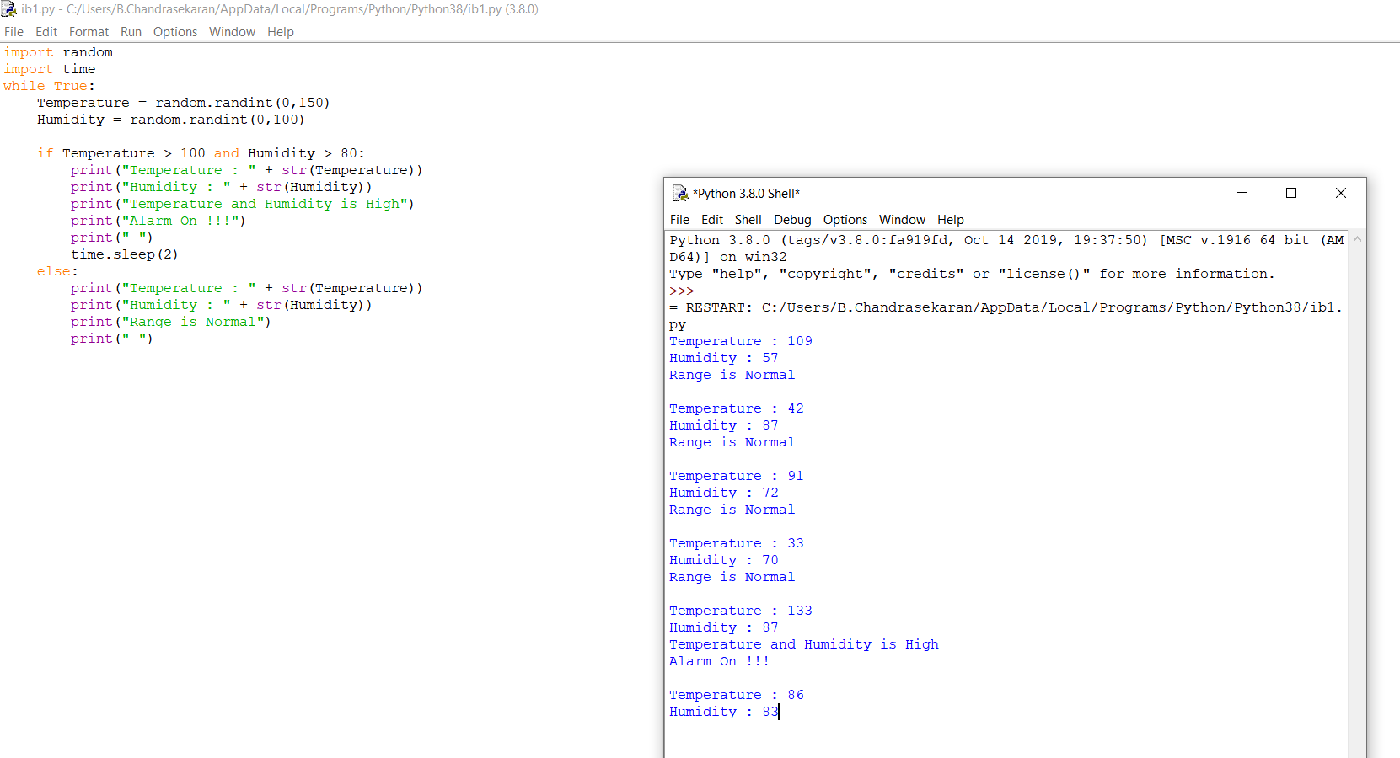

import random

import time

while True:

Temperature = random.randint(0,150)

Humidity = random.randint(0,100)

if Temperature > 100 and Humidity > 80:

print("Temperature : " + str(Temperature))

print("Humidity : " + str(Humidity))

print("Temperature and Humidity is High")

print("Alarm On !!!")

print(" ")

time.sleep(2)

else:

print("Temperature : " + str(Temperature))

print("Humidity : " + str(Humidity))

print("Range is Normal")

print(" ")

import random

import time

while True:

Temperature = random.randint(0,150)

Humidity = random.randint(0,100)

if Temperature > 100 and Humidity > 80:

print("Temperature : " + str(Temperature))

print("Humidity : " + str(Humidity))

print("Temperature and Humidity is High")

print("Alarm On !!!")

print(" ")

time.sleep(2)

else:

print("Temperature : " + str(Temperature))

print("Humidity : " + str(Humidity))

print("Range is Normal")

print(" ")